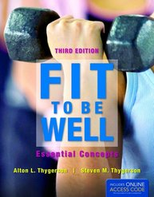
Transition Guide
Fit to be Well: Essential Concepts,
Third Edition
Alton L. Thygerson, EdD, FAWM & Steven M. Thygerson, PhD, MSPH
ISBN-13: 978-1-4496-6140-3 • Paperback • 392 Pages • ©2013
New to the Third Edition
- Life expectancy
- Exercising in the heat, cold, at high altitudes, and in areas with high air pollution
- Cross-training and interval-training
- How to overcome excuses for not exercising
- Emphasizes the FITT formula for designing an effective exercise program
- New chapter on the health benefits from physical activity and exercise adapted from Physical Activity Guidelines for Americans
- Emphasis on the Heart Rate Reserve (HRR) to calculate your intensity training range
- Walking techniques, how to gauge walking speeds, and pedometers
- Emphasis on Waist-to-height ratio (WHtR), as a much better measure of obesity.
  - Also included: BMI, waist-to-hip ratio, and waist circumference for assessing obesity.
- Content from the latest Dietary Guidelines for Americans with its emphasis on weight control and which foods to increase and to reduce
- MyPlate guidelines replace the heavily criticized MyPyramid recommendations
- Content from the latest Physical Activity for Americans
- Healthy People 2020 topics and objectives
- New labs:
  - Online Diet Analysis
  - Fast-food Analysis
  - Food Labels
  - Grocery Store Scavenger Hunt

