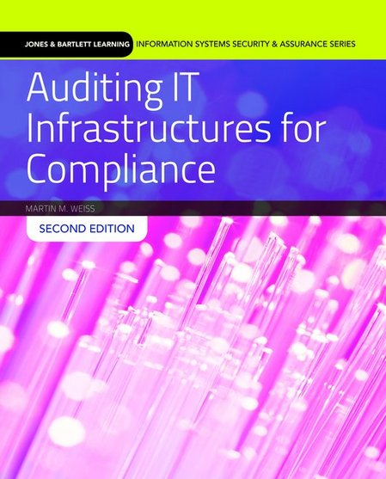

Auditing IT Infrastructures for Compliance
Second Edition
Transition Guide

By Martin Weiss & Michael Solomon
ISBN-13: 9781284090703
Paperback • 400 Pages • ©2016

Main Updates

- New studies and statistics throughout
- Includes references to updated federal laws, including FISMA and the DoD
- Includes references to updated standards such as COBIT, SANS, ISACA, ISO/IEC 27001 and CRMA
- Discusses new technology including social networking sites and electronics
- Incorporates new and updated tables and figures
- Provides new website resources, key concepts and terms, and assessment questions

Major Chapter Changes Are Listed Below
Chapter 1
- Material on the integrity of information systems updated
Chapter 2
- Material on IT compliance requirements updated
- Information on regulatory agencies added
- Federal Information Security Management Act of 2002 (FISMA) updated to include information regarding 2014 amendment by Federal Information Security Modernization Act
- “Laws and Regulations of the DoD” section updated to clarify information on The Paperwork Reduction Act of 1995, the Clinger-Cohen Act of 1996, and the E-Government Act of 2002
- Information added on NIST six-step risk management framework (RMF), as well as a comparison between RMF and C&A
- Figure 2-1 updated
- Information Assurance (IA) replaced with cybersecurity
- New section “Children’s Online Privacy Protection Act (COPPA)” added
Chapter 3
- Definitions added for gap analysis, identity theft, privacy office, LAN, and WAN
- Information on SANS updated to include 2013 transfer of Critical Security Controls to Council on CyberSecurity
- Description of 20 critical controls updated
- Table 3-2 updated
Chapter 4
- Information on COBIT updated due to 2014 changes and to reflect COBIT 5
- Information on ISACA added
- Figure 4-2 updated
- “SAS 70 Compliance” section replaced with “Service Organization Control (SOC) Reports” section
- Additional information security series included
- Table 4-3 replaced with new Table 4-2
- Information on ISO/IEC 27001 updated
- Section on the NIST “Cybersecurity Framework” added
Chapter 5
- Definitions added for scope creep and CPO
- “Threat Analysis” section updated
- Information on quantitative risk analysis added
- COBIT control objectives updated
- Consensus Audit Guidelines updated to Critical Security Controls
Chapter 6
- Topics and Goals updated
- Various line edits
- Key Concepts and Terms updated with new entries
- Assessment Questions updated
Chapter 7
- Topics and Goals updated to reflect new sections
- “Maturity modeling” section replaced and updated
- Tables 7-2, 7-3, and 7-6 updated
- Key Concepts and Terms updated with new entries
- Assessment Questions updated
Chapter 8
- Key Concepts and Terms updated with new entries
- Various line edits
- Assessment Questions updated
Chapter 9
- New Figure 9-2
- Technology references updated to include smartphones, tablets, etc.
- “Wardialing” and “wardriving” entries updated
- Key Concepts and Terms updated with new entries
- Assessment Questions updated
Chapter 10
- Table 10-2 updated
- Definitions added for WLANs and networking devices
- New website resources added
- Key Concepts and Terms updated with new entries
- Assessment Questions updated
Chapter 11
- New website resources added for network management tools and NAC software products
- Key Concepts and Terms updated with new entries
- Various line edits
- Assessment Questions updated
Chapter 12
- New section on “cloud computing”
- Figure 12-4 updated
- New website resources added for WAN optimization tools
- Section on “WAN Service Provider SOC Compliance” updated
- Table 12-5 updated
- Key Concepts and Terms updated with new entries
- Assessment Questions updated
Chapter 13
- User Datagram Protocol (UDP) defined
- A-I-C updated to C-I-A
- Various line edits
- Key Concepts and Terms updated with new entries
- Assessment Questions updated
Chapter 14
- A-I-C updated to C-I-A
- New website resources added for application performance monitoring software
- Table 14-3 updated
- Key Concepts and Terms updated
- Assessment Questions updated
Chapter 15
- “ISACA seven guiding principles” updated
- URLs updated
- “(ISC)² Code of Ethics” updated with new information regarding the Certified Authorization Professional (CAP), Certified Cyber Forensics Professional (CCFP), and Healthcare Information Security and Privacy Practitioner (HCISPP) certifications
- “CompTIA certifications” updated to include the CompTIA Cloud, Mobility, Storage, Cloud Essentials, Healthcare IT Technician, Social Media Security Professional (SMSP), IT Fundamentals, and Advanced Security Practitioner (CASP) certifications
- New section on “Certification in Risk Management Assurance (CRMA)” added
- “SANS” section updated with new 2015 data and updated Table 15-1 on Global Information Assurance Certification (GIAC) programs
- Key Concepts and Terms updated with new entries
- Assessment Questions updated

