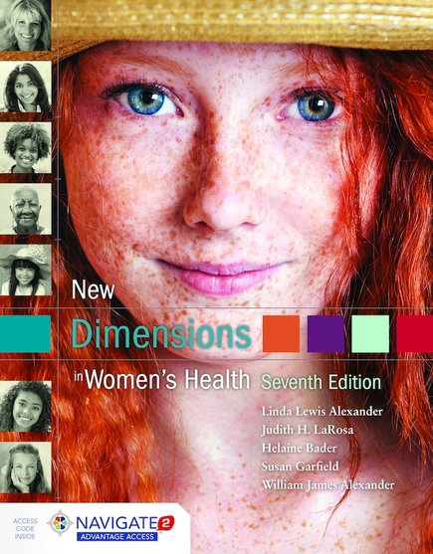

New Dimensions in Women’s Health
Seventh Edition
Transition Guide

By Linda Lewis Alexander • Judith LaRosa• Helaine Bader
Susan Garfield • William James Alexander
ISBN-13: 9781284088434
Paperback with Navigate 2 Advantage Access
550 Pages • ©2017

NEW TO THIS EDITION
The seventh edition of New Dimensions in Women’s Health has been extensively expanded, updated, and revised to include the most accurate and relevant women’s health information in an organized, engaging manner. It includes new developments in women's health as well as practical ways women can improve their own health.

Highlights include:
■ New material discussing healthcare reform and its implications for individual women and the country as a whole (Chapter 1)
■ New discussion of the growing grey area and cultural influence of marijuana (Chapter 13)
■ New section on electronic cigarettes and vaping and their implications for public health (Chapter 13)
■ New sections offering practical tips and strategies for individuals who wish to quit smoking, reduce problem drinking or quit illicit drug use (Chapter 13)
■ New section on abuse/misuse of prescription and over-the-counter drugs (Chapter 13)
■ New section on dissociative disorders, including common forms of these disorders, how they occur and their effects on the psyche (Chapter 12)
■ NEW “Critical thinking” cases that involve detailed discussions of women dealing with issues discussed in relevant chapters, including smoking, sexually transmitted infections, and mental illness. Each of these case studies includes discussion questions and answers. (All chapters)
■ NEW Explanation of the endocrine system (Chapter 11)
■ Expanded discussions of women’s health from a global perspective, with discussions of how women’s health issues in developing countries, Canada and Europe compare to those in the United States (Chapter 1)
■ Expanded discussion regarding gender identity, transgender, and gender neutral (Chapter 4)
■ Expanded practical, detailed information about HPV, including information about vaccinations, Pap smears and HPV testing, the advantages and disadvantages of each of these, and how to evaluate one’s own risk for HPV and other STIs. (Chapter 7)
■ Expanded discussion of STI risk for LBGT populations and how to reduce risk (Chapter 7)
■Expanded discussion of menopause as a natural part of a woman’s life cycle, the “medicalization” of menopause, and how hormone therapy works. (Chapter 8)

■ Expanded section on stress, including the biology of the stress response, the health effects of short-term and long-term stress, sources of stress and how to cope in a healthful manner. (Chapter 12)
■Updated to reflect the latest developments in the HIV/AIDS epidemic in the U.S. and around the world, as well as the latest efforts to reduce transmission and increase treatment. (Chapter 7)
■ An updated legal perspective on marriage for same-sex couples (Chapter 4)
■ Updated section on global tobacco use and the health effects of smoking around the world (Chapter 13)
■ Updated information on mental illnesses to discuss new DSM-V (Chapter 12)
■ Greatly updated section on suicide, including an expanded discussion of suicide as a global public health problem (Chapter 12)

