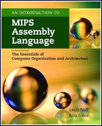
An Introduction to MIPS Assembly Language
to Accompany The Essentials of Computer Organization and Architecture
Available as an e-PDF when bundled with the main text using
ISBN: 978-1-284-10845-3

Table of Contents:
- Introduction
- The MIPS Architecture
- MIPS Assembly Programming Environment
- MIPS Instructions
- Arrays and Strings
- Subroutines
- Summary

