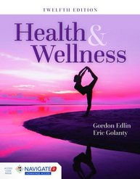
Health & Wellness
TWELFTH EDITION
Navigate 2 Animations

Animation Title | Chapter | Page
The Digestive System | 5 | 101
Sports Nutrition: ATP-CP Energy | 7 | 165
The Female Reproductive System | 8 | 176
The Male Reproductive System | 8 | 181
Childbirth | 9 | 208
Immune System | 12 | 266
Antibody Function and Antigen Clearance | 12 | 273
Cell-Mediated Immunity | 12 | 273
Antigen Presentation | 12 | 274
The Chain of Infection | 12 | 288
How Cancer Cells Multiply and Spread | 13 | 296
Environmental and Lifestyle Risk Factors that Contribute to Cancer | 13 | 301
Diet & Health: Development of Atherosclerosis | 14 | 324
An Arterial Stint | 14 | 325
Balloon Angioplasty | 14 | 325
CT Scan of Stroke Victim | 14 | 328
Steps Required by the FDA for Reviewing a New Drug | 16 | 371
Brain’s Reward Center | 16 | 373
A Healthy Lung and the Lung from a Person with Emphysema | 17 | 396
The Health Consequence of Repeated Exposure to Secondhand Smoke | 17 | 396

