

This item was created as a helpful tool for you, our valued customer.

It is not intended for resale, dissemination, or duplication.

***Invitation to Oceanography***

*Seventh Edition*

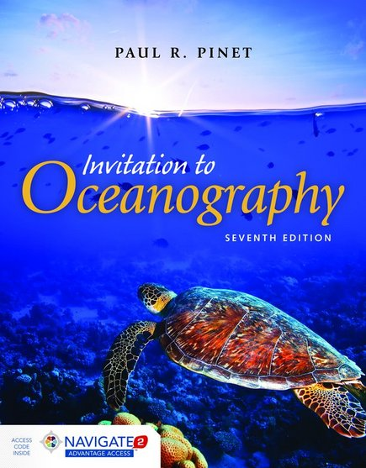

**Paul R. Pinet**, PhD, Colgate University

ISBN-13: 9781284057072

Paperback with Access Code • 620 Pages • © 2016

Jones & Bartlett Learning

**SEE WHAT’S NEW TO THE SEVENTH EDITION!**

This Transition Guide outlines many of the changes and new content in the *Seventh Edition*. Use this guide for an easy transition to the new edition.

**KEY UPDATES:**

* Learning Objectives are now included with every chapter in the print book to focus the students’ attention
* Updated design highlights key pedagogical features
* Emphasizes current research and real-world, clinical applications
* All graphics and icons have been updated to be more visually appealing, sophisticated, and intuitive.
* Includes NEW content on global and climate change, Hurricane Sandy, and the tsunami in Japan

**SUPPORT FOR INSTRUCTORS**

* Sample Syllabus
* Lecture Slides in PowerPoint format
* Test Bank Materials
* Key Image Review
* Instructor’s Manual, which includes Learning Objectives, Teaching Tips, Chapter Outline, and Answer Key for End-of-Chapter Questions
* Navigate 2 platform with course management tools, including an Assessment center with prepopulated quizzes and exams and Study Tools for your students

**EACH NEW BOOK COMES WITH NAVIGATE 2**

Each new book now comes packaged with access to Jones & Bartlett Learning’s Navigate 2 learning solution package at no extra cost. Navigate 2 delivers unbeatable value to students and instructors alike. Some of the unique features include:

* A complete interactive eBook with on-page practice questions, links to useful websites, and other interactive learning and study features
* A virtual Study Center with Practice Activities and other learning tools for students
* An Assessment center with prepopulated quizzes and exams for instructors to assign
* An instructor’s dashboard that reports actionable data on student use and progress

**Students will also have the option to purchase the Navigate 2 digital-only access which includes the interactive eBook for half the price of the print book.**