Chapter 5
Introduction to Word Processing
Lab 1
Mail Merge Lab

1. Create a Microsoft Word document, or use the sample document provided.

2. On the top of the ribbon, click on the Mailings tab.

3. Click on Start Mail Merge.

4. Click on Step by Step Mail Merge Wizard.

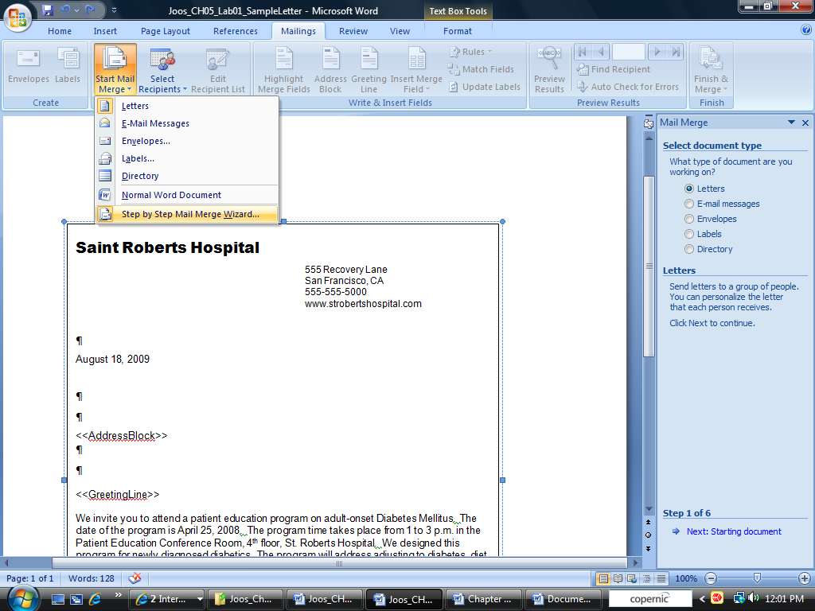

a. On the right hand side, a dialog box will appear. Select Letters. Then click Starting
Document.

b. Under Select Starting Document, choose Start from a template. Then choose
Select template.

c. Choose the desired template.

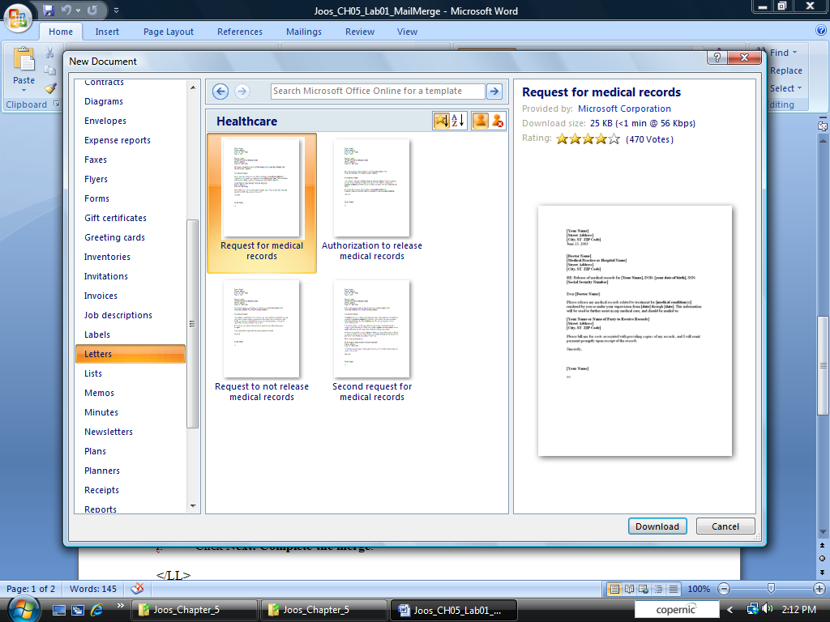

d. Edit the letter as appropriate.

e. Click on Next: Select Recipients

f. Choose Use an existing list

g. Use the Browse button to select your recipient list. Select it.

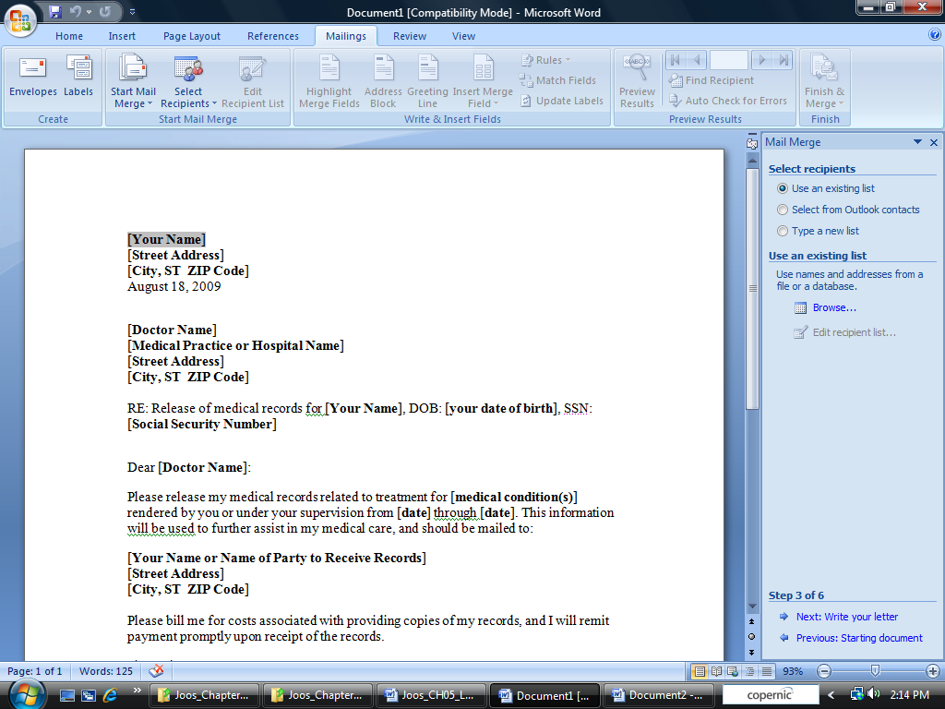

h. Click Next: Write your letter.

i. Edit the Address Block and Greeting line as desired.

j. Click Next: Complete the merge.

5. Print one letter and give it to your instructor.

